Cucumber Grow Bags

Botanicoir Breeze is very popular amongst growers as it offers a relatively dry growing environment with a flexible water holding capacity to enable maximum crop steering in a range of climates.
The incorporated husk chips encourage free drainage and promote generative growth in the plants from a young age.
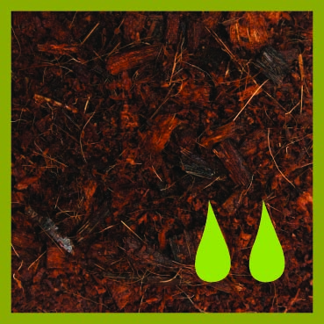
We make each product specifically to the growers needs, from the coir mix to the plastic for the bag.
Salad grow bags are available in sizes up to 120cm in length with width and height as required, and planting, dripper and drainage holes can pre-cut in the bags to the growers requirements, at no extra cost.
All of the plastic that we use is high quality, UV treated and recyclable.

Cucumber Grow Bags

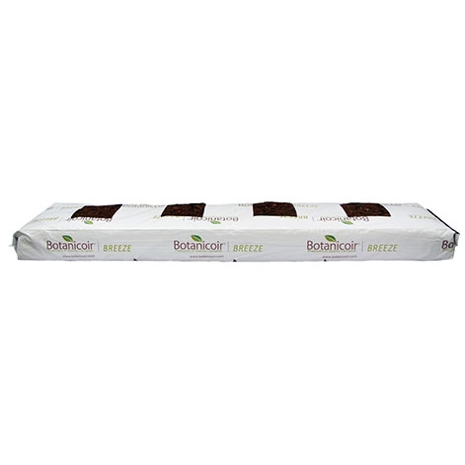

4 Holes
+ Drainage Holes & Dripper Holes
100 x 20 x 8cm
500 Units per Pallet

